SWINBURNE UNIVERSITY OF TECHNOLOGY

WEB APPLICATION DEPLOYMENT TO MICROSOFT AZURE APP SERVICE

Student Name: Karamjot Singh
Student ID: 104809887
Unit Code and Title: SWE40006 Software Deployment and Evolution
Semester: Semester 2, 2026
Submission Date: 01/09/2026
Declared Target Level: Distinction

Contents
INTRODUCTION AND SYSTEM OVERVIEW 3
The SiteWatch Application 3
Architecture 4
ENVIRONMENT AND PROVISIONED RESOURCES’ 5
Development environment 5
TASK 2.1 – PASS LEVEL 5
Account and Toolchain Setup 5
Sample Application 7
Deployment via the publish profile 10
TASK 2.2 – CREDIT LEVEL 13
Application Design 13
Deployment 16
Resource Management 17
Runtime lifecycle 17
TASK 2.3 – DISTINCTION LEVEL 19
Configuration abstraction 19
Provisioning the storage backend 19
Externalised settings 21
Demonstrating that the abstraction is effective 23
Health check endpoint 24
Diagnostic logging and real-time streaming 24
PROBLEMS ENCOUNTERED AND THEIR RESOLUTION 26
DECLARATION OF GEN AI USE 28
REFERENCES 29

Live applications for grading
Sitewatch: https://sitewatch-104809887-arcag0eygdhkc7er.australiasoutheast-01.azurewebsites.net/
Inbound ip: 13.77.50.105,20.92.54.1
swe40006-sample-104809887: https://swe40006-sample-104809887-dcbhazekcygfdzg9.australiasoutheast-01.azurewebsites.net/
inbound ip: 13.73.118.104

Source Repo: https://github.com/Karam1008/Software-Deployment-Task-2.git

INTRODUCTION AND SYSTEM OVERVIEW
This report documents the configuration, deployment and operational management of web applications on Microsoft Azure App Service using Visual Studio 2022 and the Azure Portal, submitted for Deployment Portfolio Task 2 at Distinction level. Sub-tasks 2.1, 2.2 and 2.3 were completed in sequence, and each is evidenced separately in Sections 3, 4 and 5.
Two applications were deployed. The first, required at Pass level, is an unmodified ASP.NET Core Model-View-Controller template application, deployed to demonstrate that the toolchain, subscription and publishing pipeline function end to end. The second, SiteWatch, is a purpose-built ASP.NET Core 9 application developed for Credit level and extended for Distinction level.

The SiteWatch Application
SiteWatch is an endpoint uptime monitor. It requests a configurable list of HTTP endpoints, records each response status code and round-trip latency, persists the results to Azure Table Storage, and presents them through a Razor Pages status board with recent history. It additionally exposes a JSON API at /api/status and a health endpoint at /healthz.
The application was chosen deliberately rather than for convenience. Each level of the assessment rubric requires a specific class of evidence, and a trivial application such as a calculator would provide nothing to demonstrate against. Specifically:
- Task 2.3 requires connection strings to be abstracted out of source code. A monitor that persists history to Azure Table Storage has a genuine credential that cannot safely be committed, so externalising it is a real security measure rather than a demonstration.
- Task 2.3 requires an active health check endpoint. Because SiteWatch depends on a storage backend, its health endpoint can verify that dependency and report a degraded state - a health check that is capable of failing reports meaningfully more than one that returns a constant.
- Task 2.3 requires real-time log monitoring. A monitoring application that performs outbound HTTP requests on every page load generates a continuous stream of genuine application diagnostics, rather than requiring artificial log statements to be added for the purpose of the screenshot.
A further property emerged during development and is discussed in Section 5.4: because SiteWatch measures the response time of the endpoints it checks, it recorded the cold-start behaviour of the Task 2.1 application in its own history table.

Architecture
Browser
|
v
SiteWatch (ASP.NET Core 9, Windows App Service, F1)
| |
| +--> Azure Table Storage (check history)
|
+--> outbound HTTP checks --> monitored endpoints
(incl. the Task 2.1 sample application)

Runtime configuration - the monitored endpoint list, the request timeout, and the storage connection string - is supplied entirely by Azure App Service application settings and is not present in the application source.

ENVIRONMENT AND PROVISIONED RESOURCES’

Development environment
Component | Role in this task
Windows 11 | Development host
.NET SDK 9.0.317 | Exceeds the .NET 8 or newer requirement
Visual Studio 2022 Community | C# development and App Service publishing
Microsoft Edge / Google Chrome | Live verification and Portal access
Git | Version control
Azure Portal | Provisioning, configuration and diagnostics

TASK 2.1 – PASS LEVEL
Requirement - Create an Azure account and configure an IDE with App Service publishing tools; deploy a sample web application to Azure App Service using the IDE publish profile; and confirm that the application is live and publicly accessible with a public IP address.

Account and Toolchain Setup
An Azure subscription was created, and Visual Studio 2022 Community was authenticated against it through File → Account Settings. The ASP.NET and web development workload, which supplies the Azure App Service publish target, was confirmed present in the Visual Studio Installer.
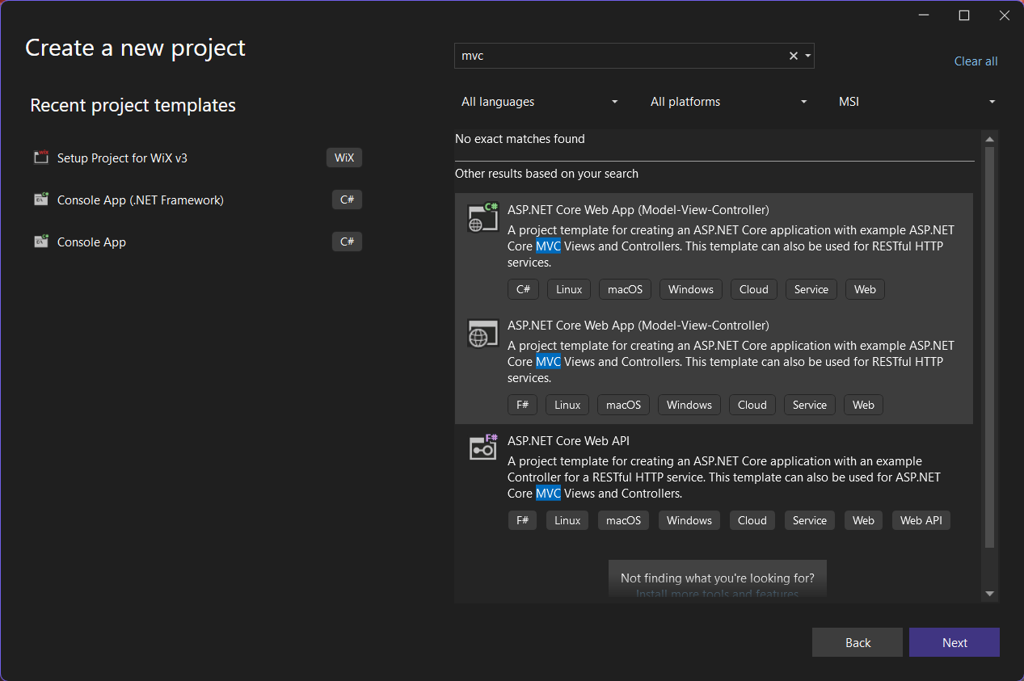

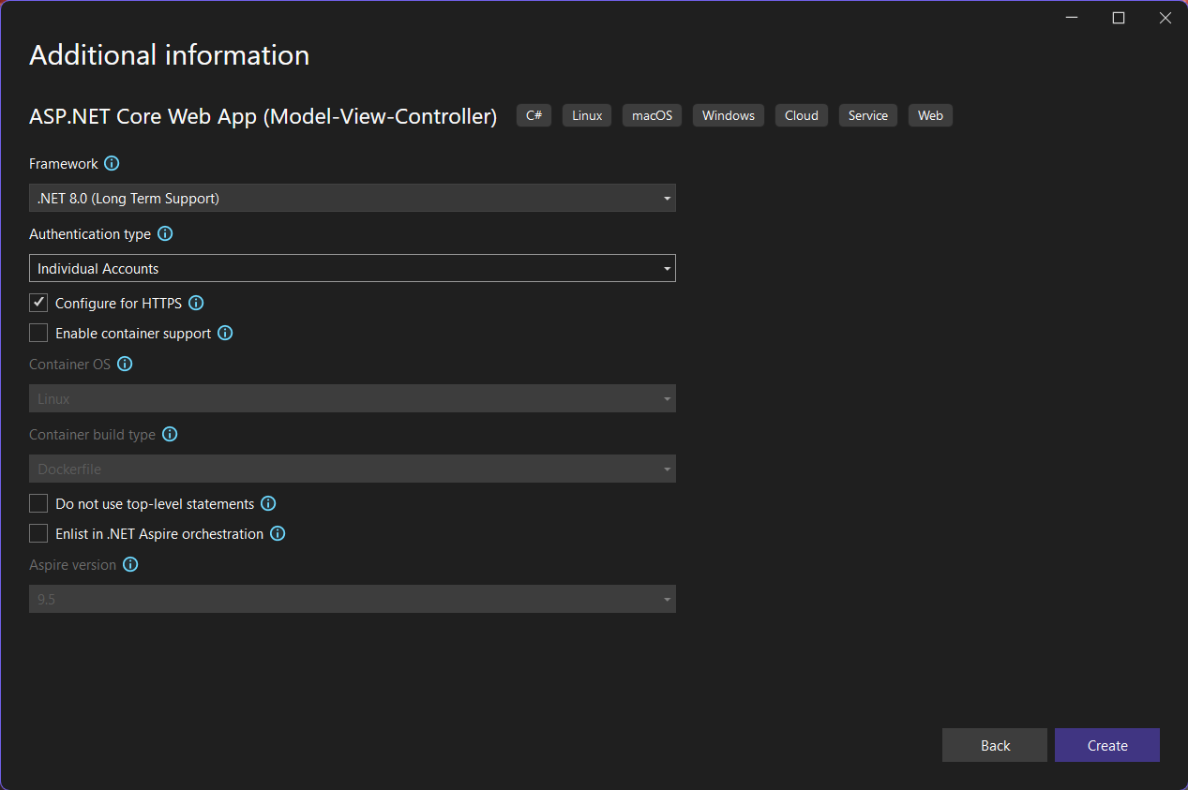

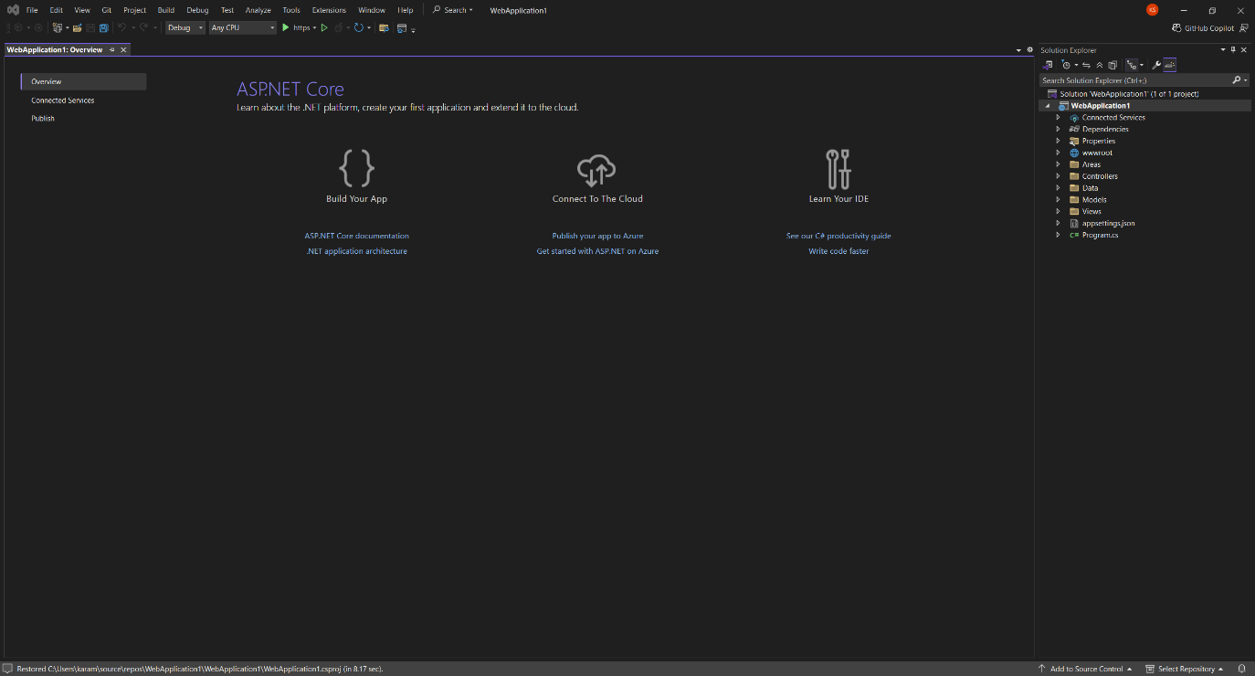

Sample Application
The sample application was created from the ASP.NET Core Web App (Model-View-Controller) project template targeting .NET 9.0, and verified on localhost before any deployment was attempted.

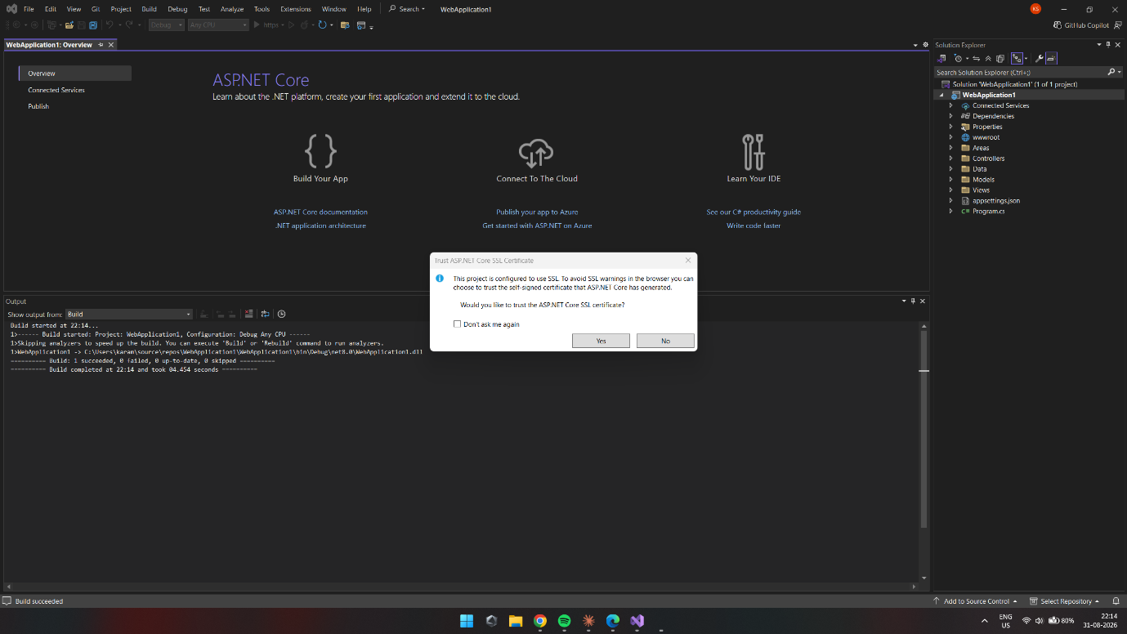
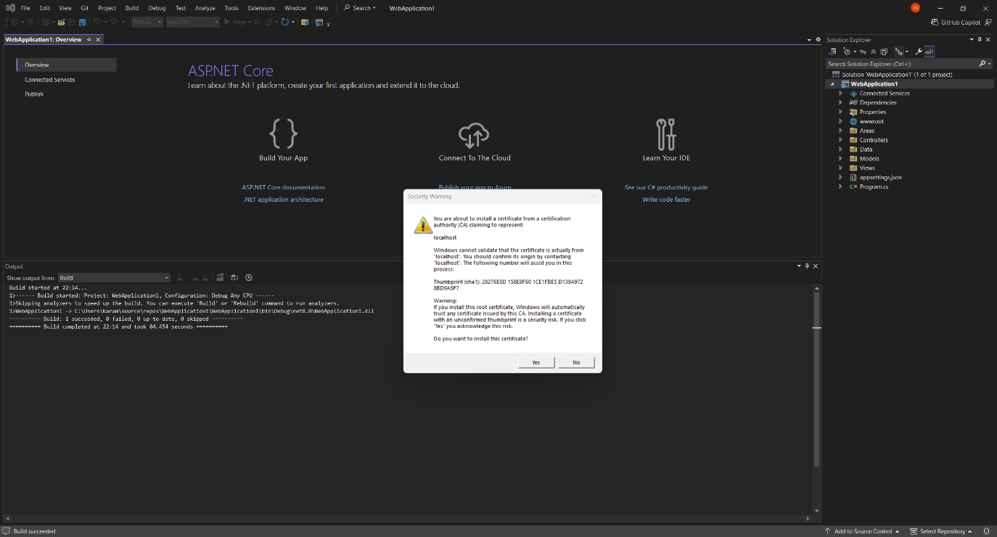

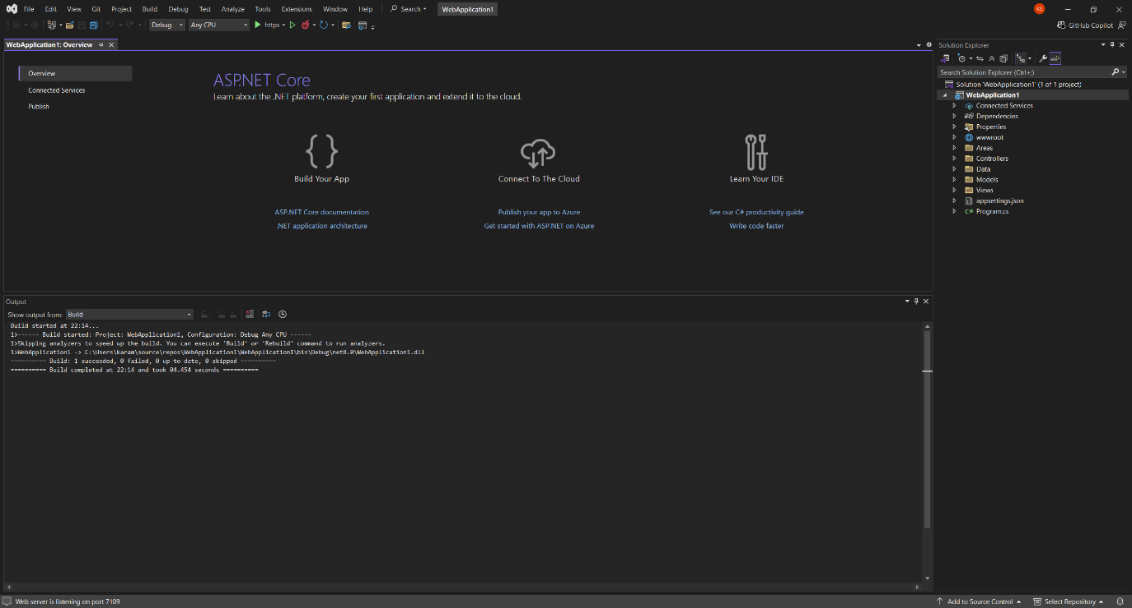
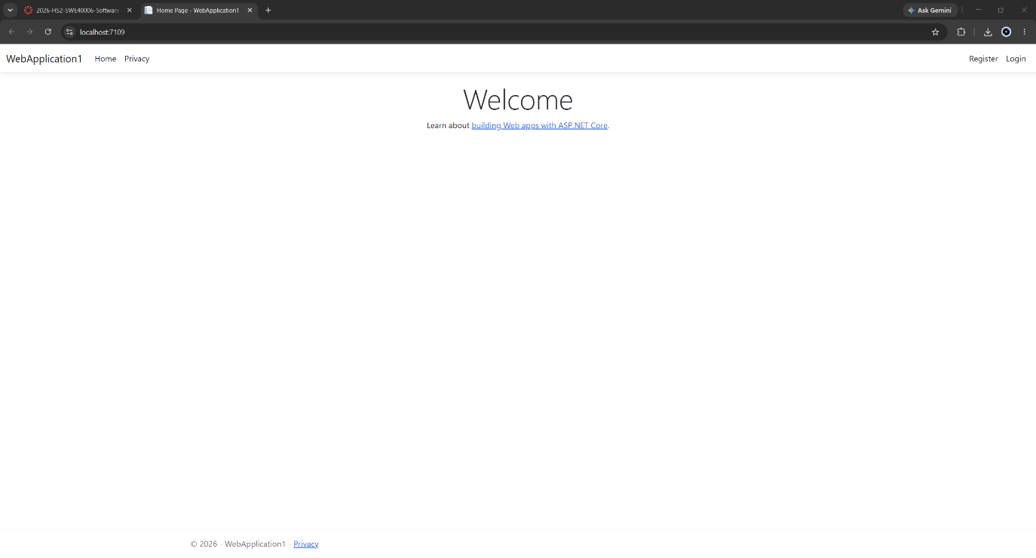

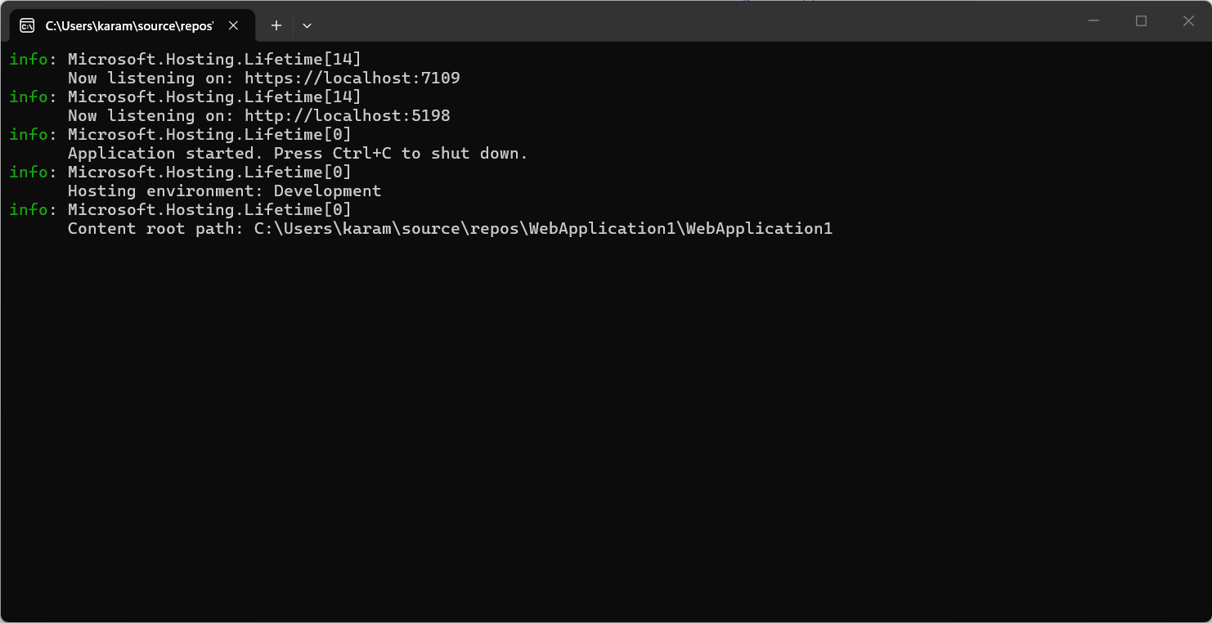

The unit walkthrough specifies Individual Accounts authentication for this template. This option was deliberately not taken. Individual Accounts scaffolds ASP.NET Core Identity together with a SQL Server connection string and an Entity Framework Core migration, none of which contribute to a Pass-level deployment demonstration, and all of which introduce a database dependency that the hosting tier is poorly suited to satisfy. Authentication was set to None. The assessment specification states explicitly that the walkthrough is a guide and that alternative approaches are acceptable provided the task objectives are met; the objective here is the deployment of a sample application to App Service, which is unaffected by the authentication choice.
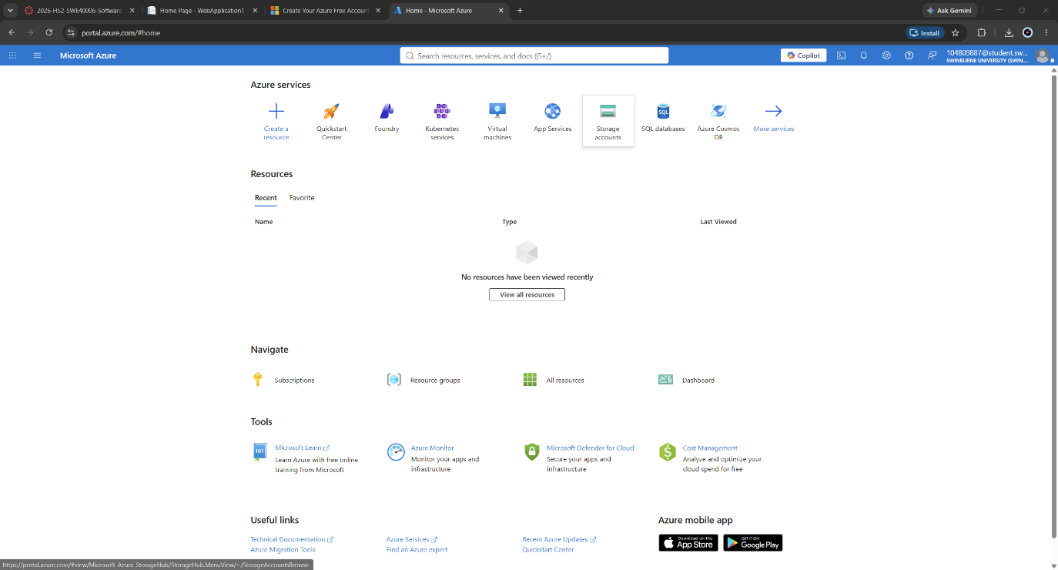

Deployment via the publish profile
Deployment was performed through the Visual Studio publish wizard.
Completing the wizard generated a publish profile (.pubxml) recording the deployment target, target framework, deployment mode and target runtime. It is important to note that completing the wizard does not itself deploy the application: it provisions the App Service and generates the profile, after which the Publish action must be invoked separately.

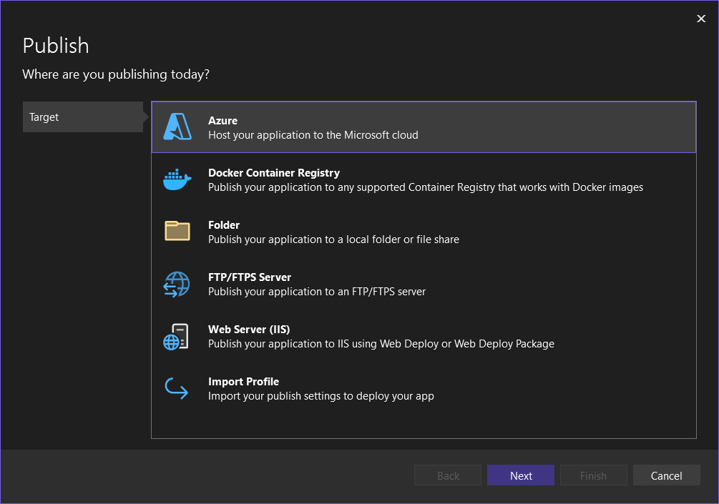

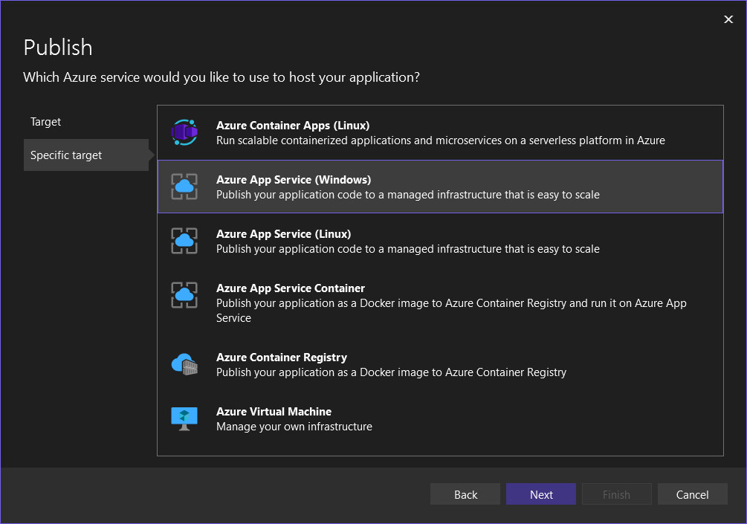

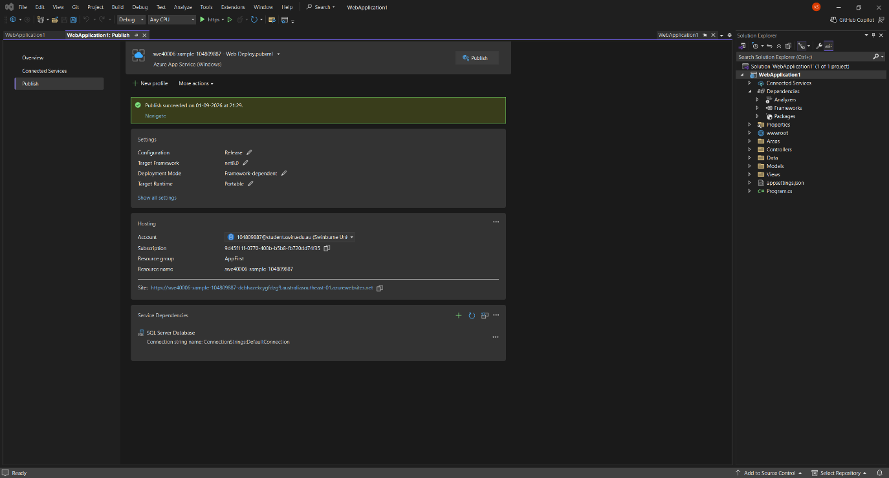

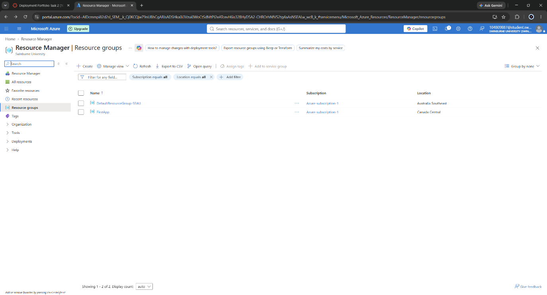

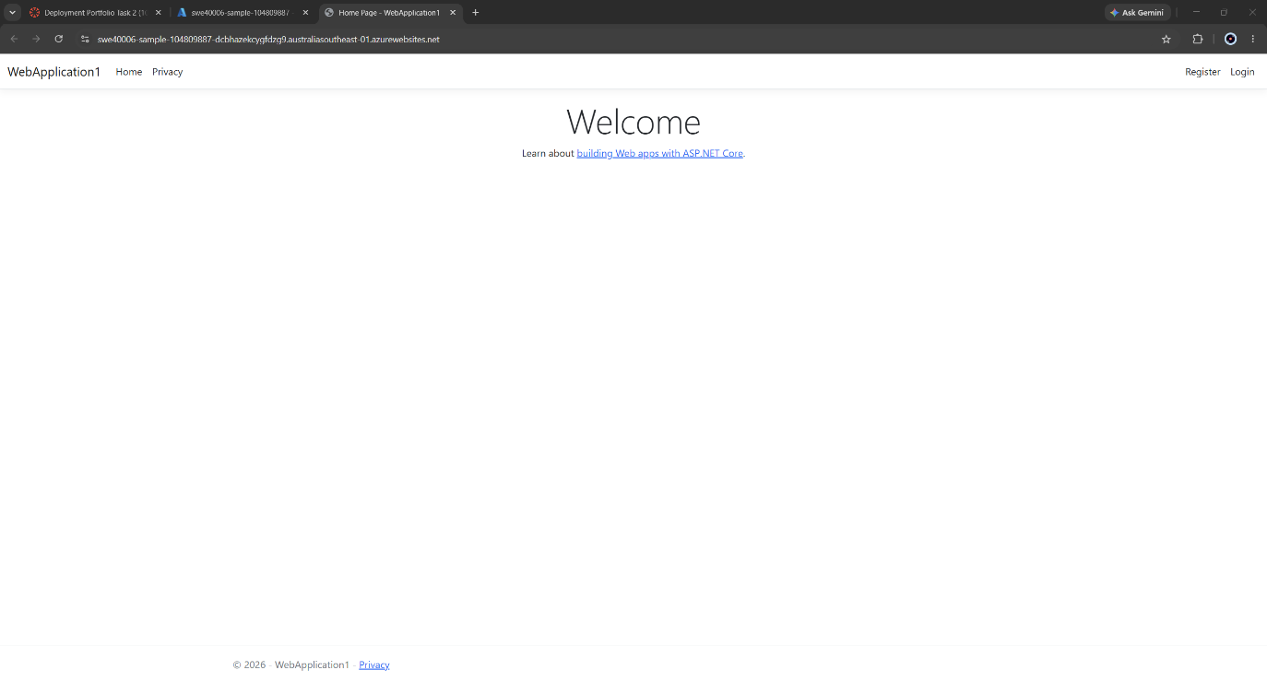

TASK 2.2 – CREDIT LEVEL
Requirement - Develop a custom C# web application targeting .NET 8 or newer using ASP.NET Core MVC, Razor Pages or Web API; publish it to Azure App Service from the IDE; and demonstrate responsible cloud resource management by stopping, deactivating or setting scaling limits on the App Service instance after verification.

Application Design
SiteWatch was built as an ASP.NET Core 9 Razor Pages application. Razor Pages was selected over MVC because the application surface consists of a single page together with a small number of endpoint handlers; the controller, view and model separation that MVC imposes would add structural ceremony without addressing any requirement of the task. The rubric permits MVC, Razor Pages or Web API, and the application in fact exposes both a Razor Pages user interface and a minimal Web API endpoint at /api/status, so more than one of the permitted forms is demonstrated.
At Credit level the application's configuration - its monitored endpoint list and request timeout - resides in appsettings.json, and no storage backend is attached; the history store operates on an in-memory buffer. This is the intended starting state rather than an oversight. Externalising that configuration into platform-managed settings is the substance of Task 2.3, and demonstrating a transition requires a prior state to transition from. The progression is visible in the repository commit history.
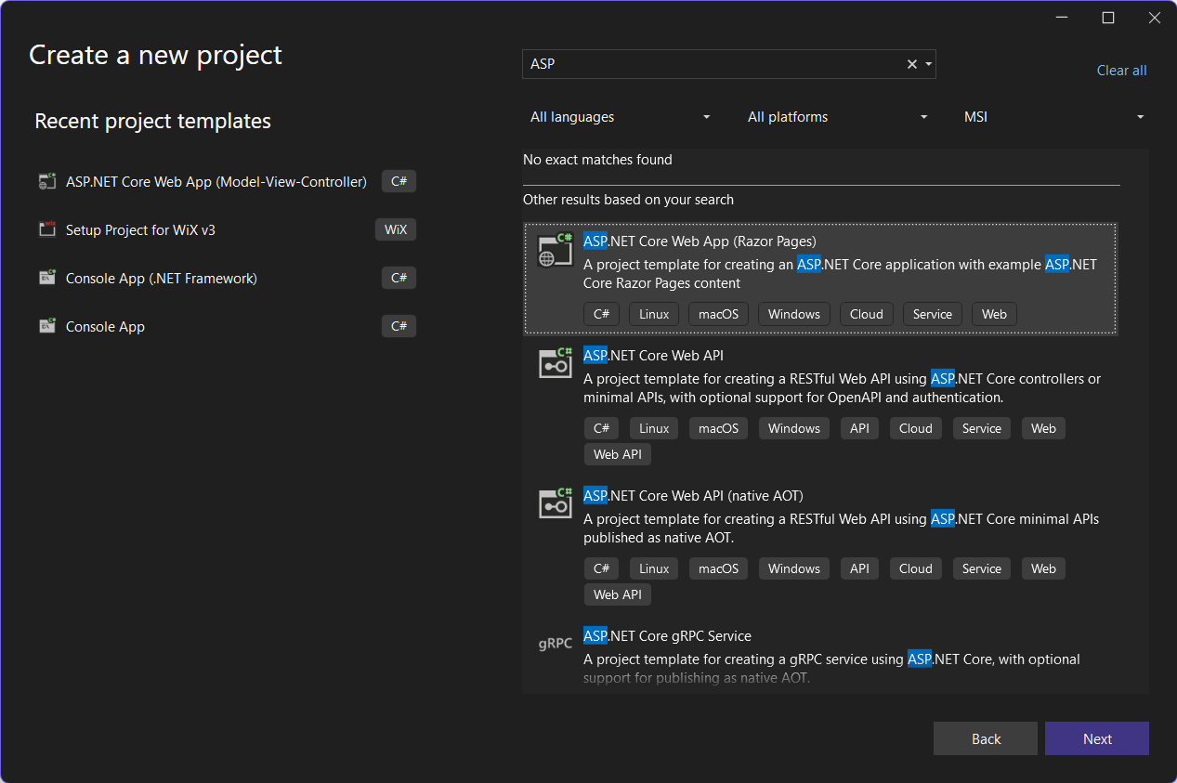
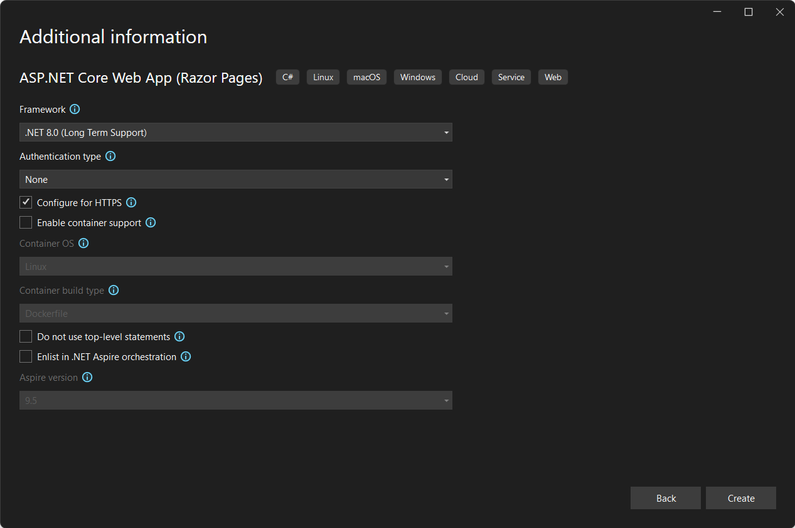

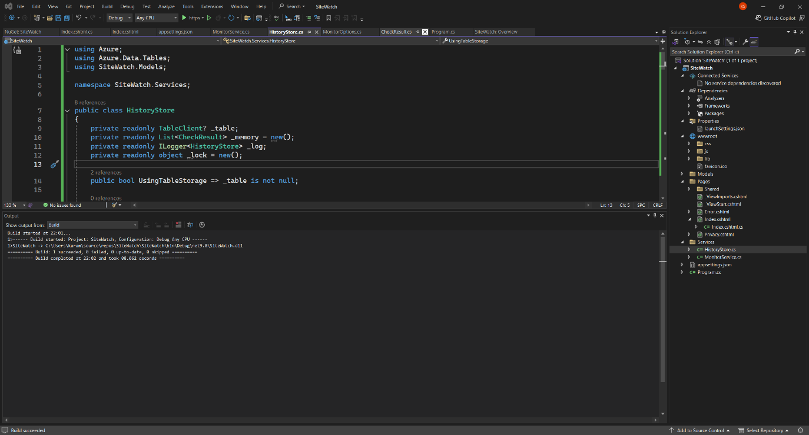
Then I installed the required NuGet Packages
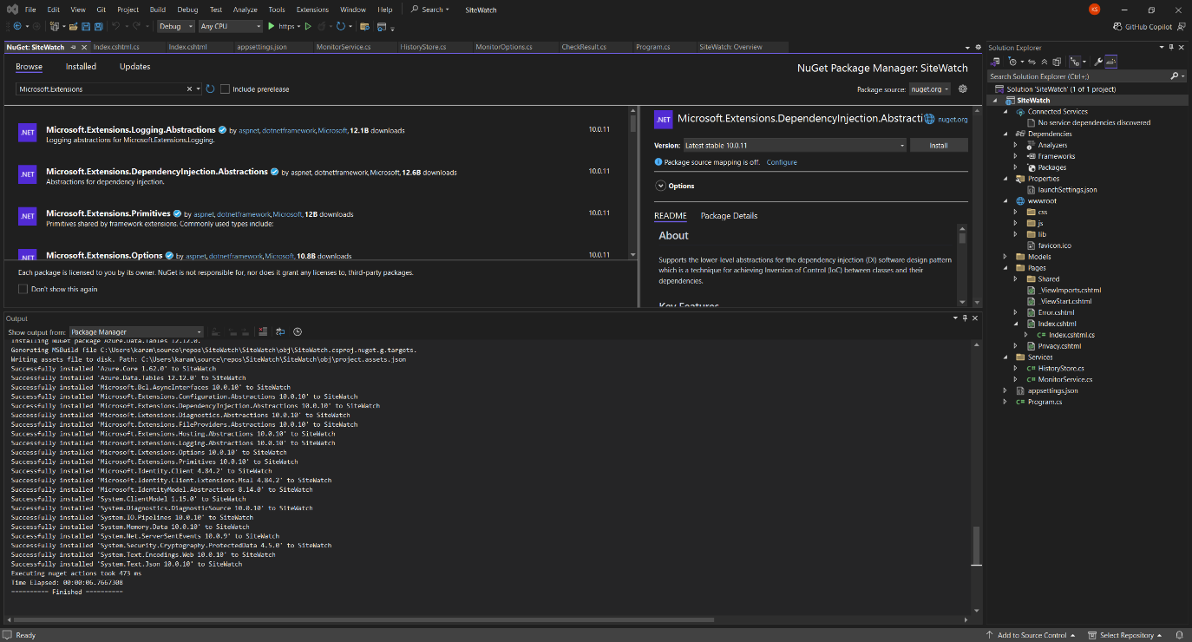
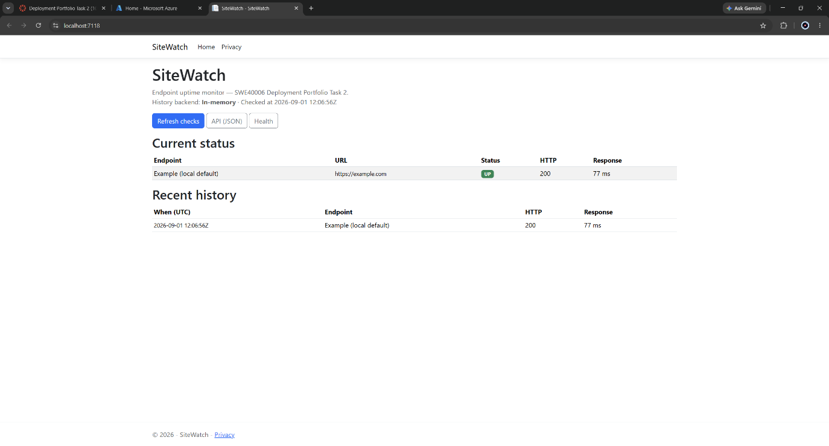

Deployment
The application was published to Azure App Service through the Visual Studio publish wizard, reusing the App Service plan created for Task 2.1 rather than provisioning a new one.
Plan reuse is a deliberate deployment-economics decision.
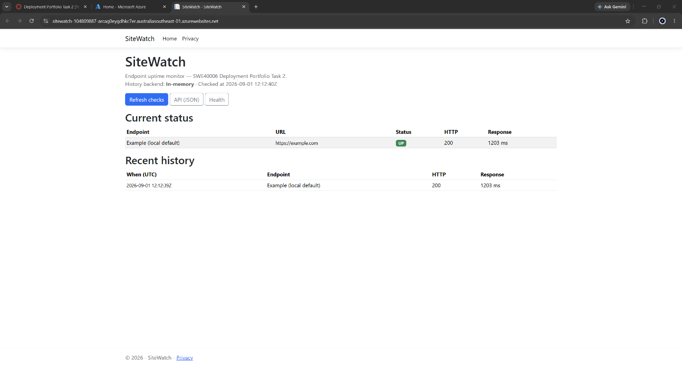

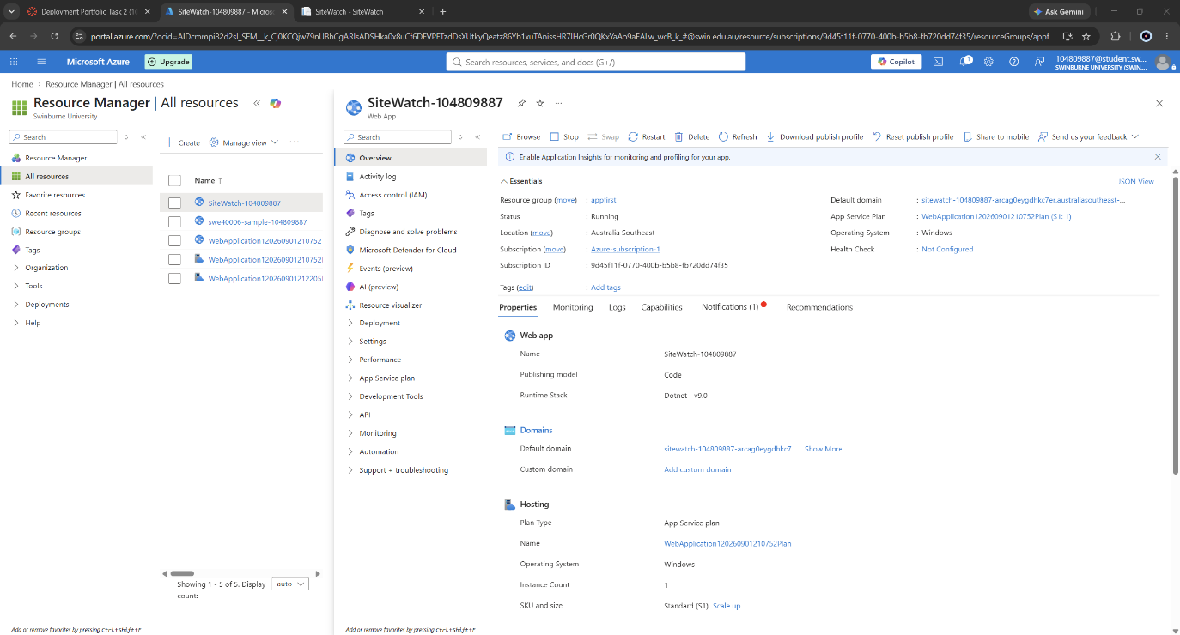

Resource Management
The rubric requires responsible cloud resource management demonstrated by stopping, deactivating or setting scaling limits after verification. Three distinct controls were exercised, addressing compute cost, financial exposure and runtime state respectively.

Runtime lifecycle
The application was stopped from the Azure Portal after verification. Deactivation was confirmed externally rather than by reading the Portal status indicator alone: a request to the live URL while the application was stopped returned an HTTP 403 response from the platform, independently confirming that the application was no longer serving traffic.
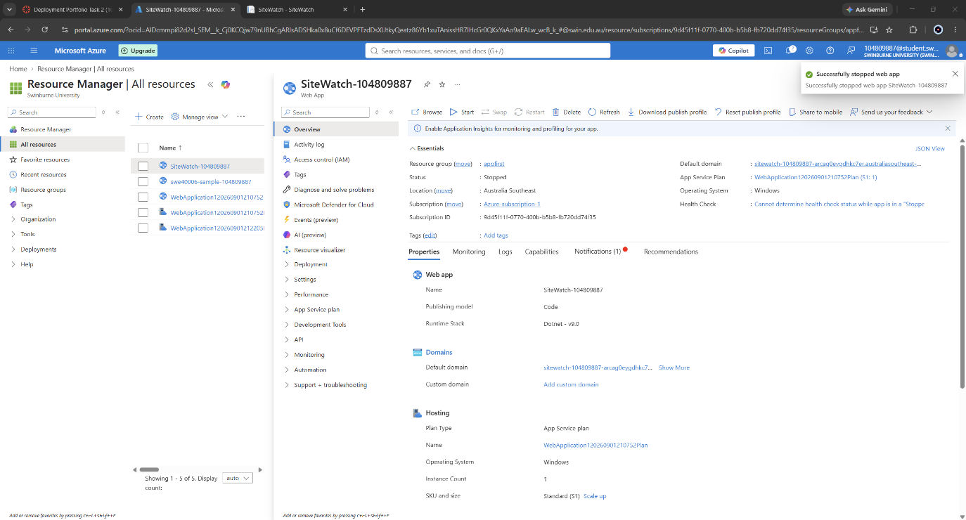

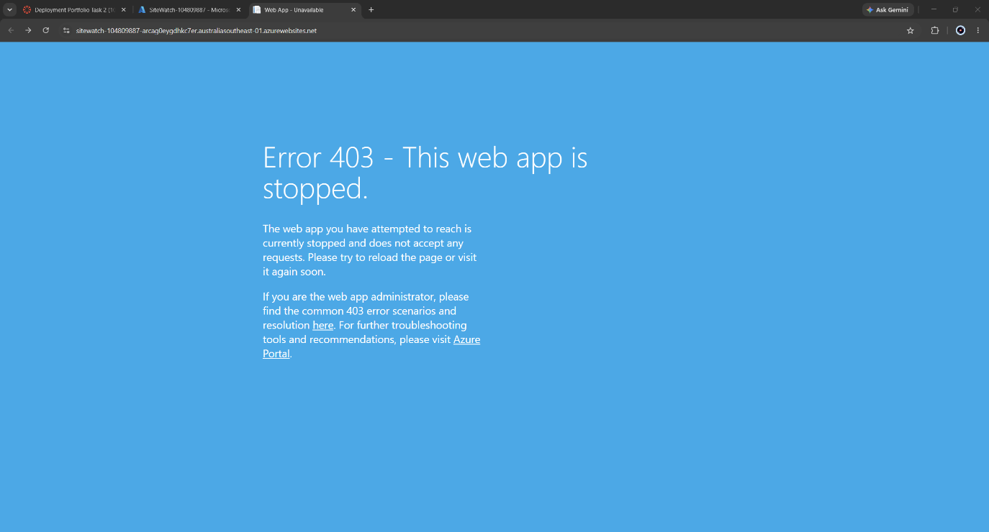

The application was then restarted and verified as serving normally.
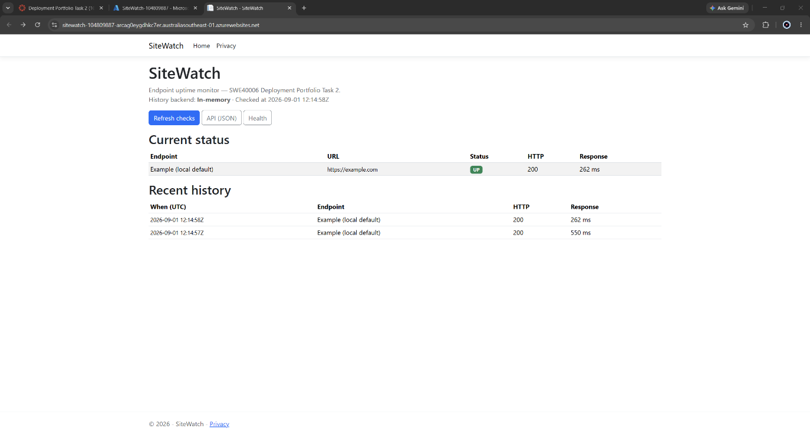

TASK 2.3 – DISTINCTION LEVEL
Requirement - Abstract connection strings, runtime keys or environment settings out of hardcoded source code and configure them securely using Azure App Service environment variables and application settings; and implement an active health check endpoint or configure Azure App Service Application and Web Server logging to monitor live HTTP request logs and diagnostic execution in real time.

Configuration abstraction

Provisioning the storage backend
A StorageV2 account with locally redundant storage was provisioned to hold endpoint check history. Locally redundant storage was selected over geo-redundant or zone-redundant options deliberately: the stored data is reconstructible operational telemetry with no durability requirement beyond the assessment period, and cross-region replication carries a cost multiplier for no corresponding benefit in this context.
The resulting connection string grants full data-plane access to the storage account and is therefore a live credential. It appears nowhere in the application source. The repository contains no connection string, no account key and no secret of any kind; this is verifiable by inspection of the linked public repository.
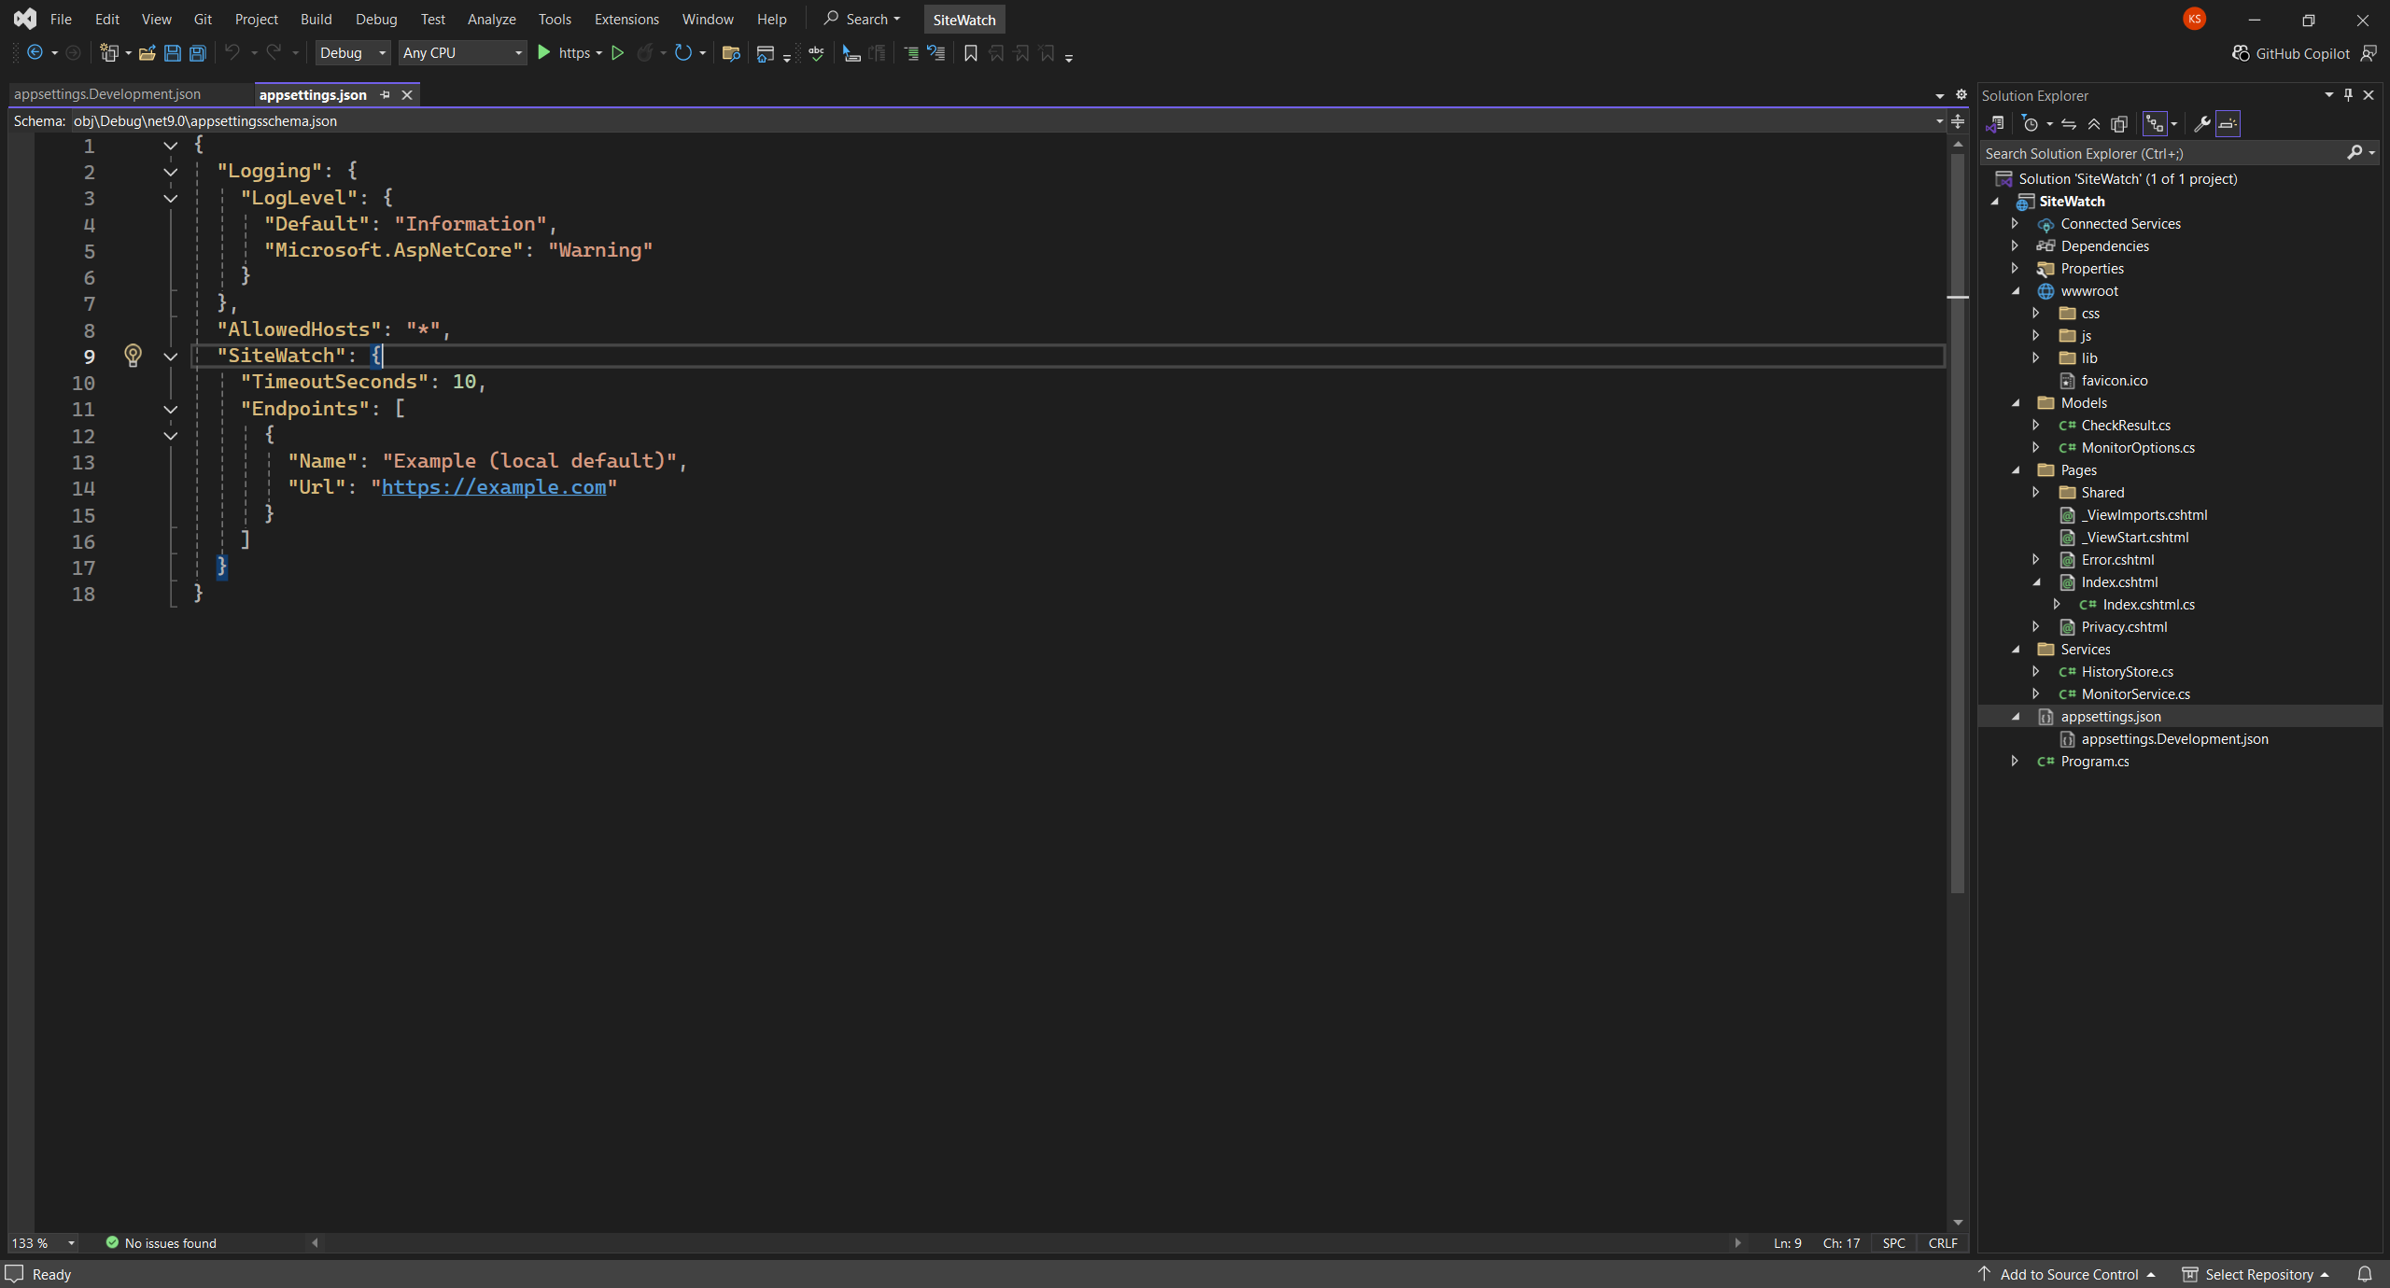

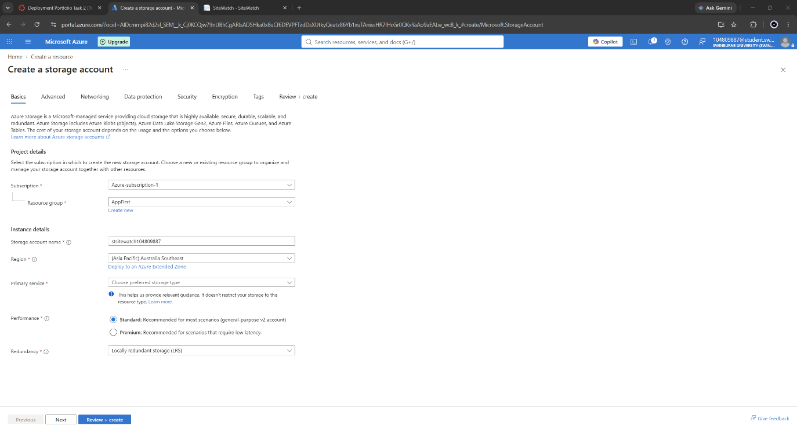

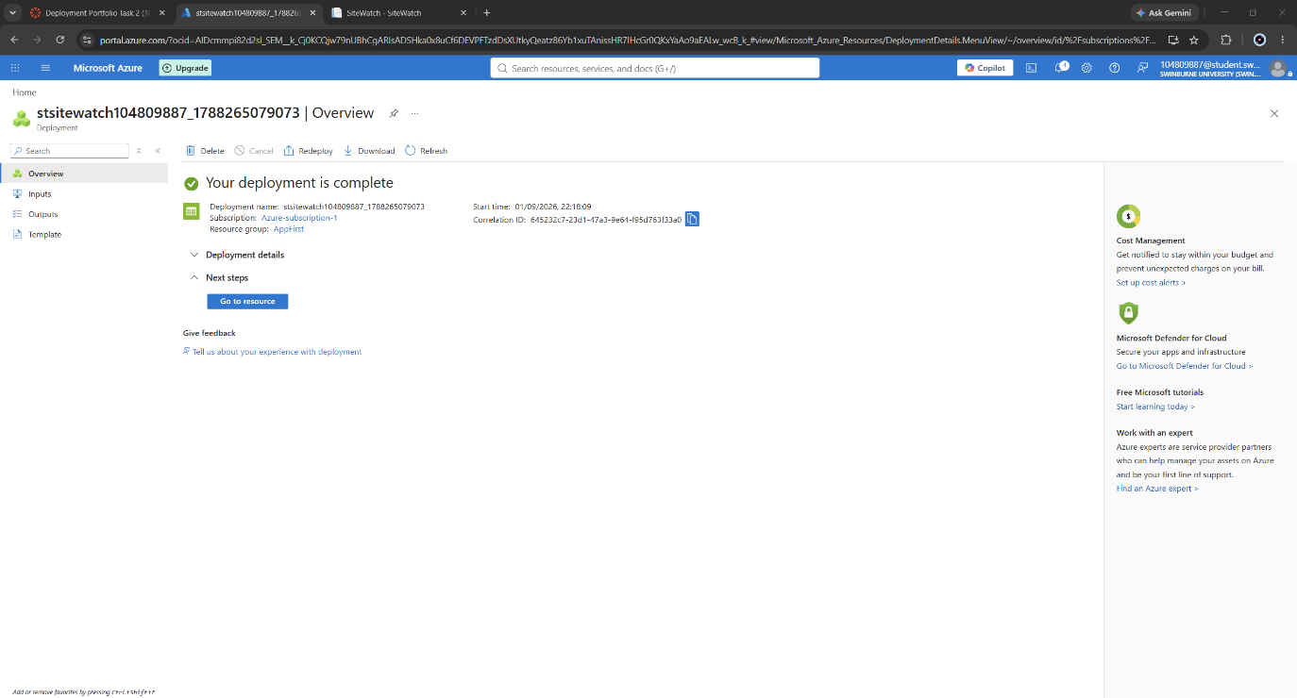

Externalised settings
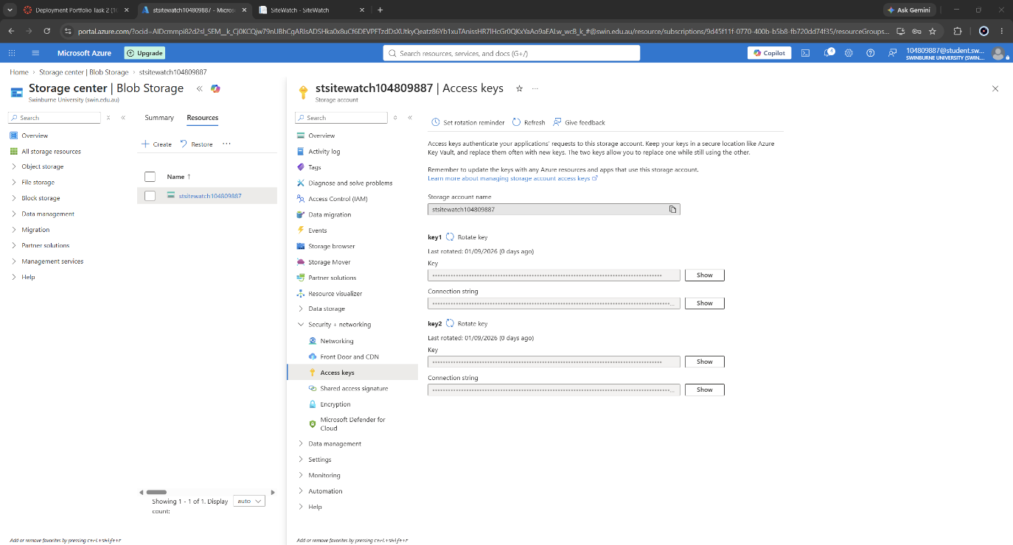

The following values were configured as Azure App Service application settings through the Portal Environment variables blade:
Application setting | Purpose
ConnectionStrings__Storage | Azure Table Storage connection string (redacted in all evidence)
SiteWatch__TimeoutSeconds | Per-check HTTP request timeout
SiteWatch__Endpoints__0__Name | Display name of the first monitored endpoint
SiteWatch__Endpoints__0__Url | URL of the first monitored endpoint
SiteWatch__Endpoints__1__Name | Display name of the second monitored endpoint
SiteWatch__Endpoints__1__Url | URL of the second monitored endpoint
SiteWatch__Endpoints__2__Name | Display name of the third monitored endpoint
SiteWatch__Endpoints__2__Url | URL of the third monitored endpoint

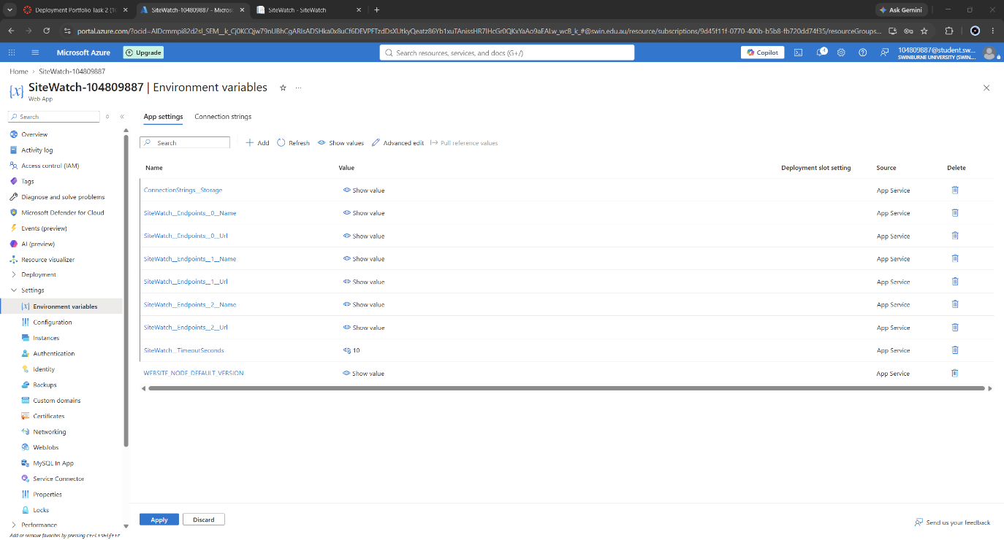

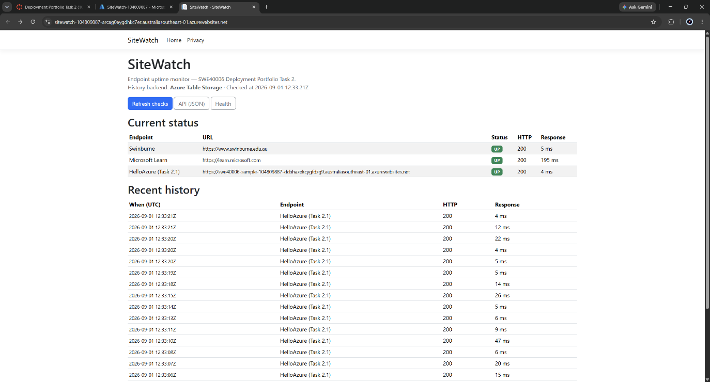

Demonstrating that the abstraction is effective
No change to application code was required in order to consume these values. The App Service configuration provider is inserted above the JSON file provider in the ASP.NET Core configuration precedence order, so platform-supplied settings override values compiled into the application automatically. That property is the practical argument for externalised configuration, and it is demonstrated directly rather than asserted.
The appsettings.json file retained in source declares a single unrelated placeholder endpoint. The deployed application monitors three entirely different endpoints, which exist only as Azure application settings. The divergence between the file and the running application is therefore evidence that platform configuration is genuinely overriding compiled configuration, rather than that the two happen to agree.

The persistence of check history across application restarts confirms that the storage connection string bound correctly and that the application is writing to Azure Table Storage.
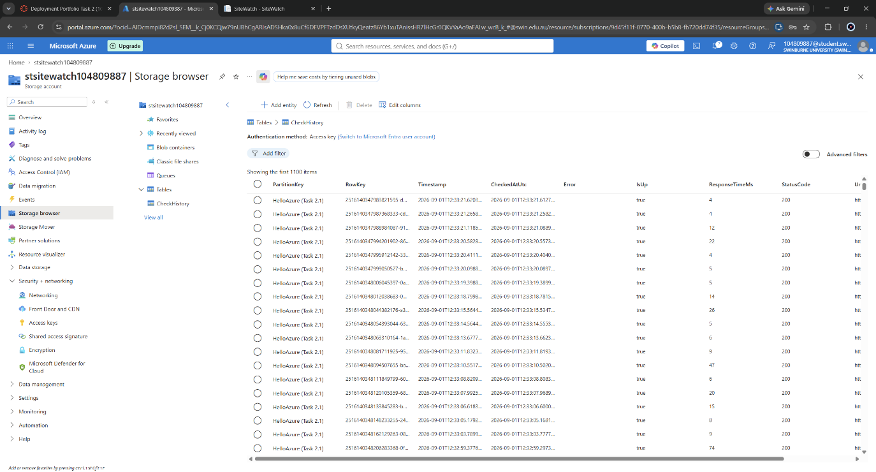

Health check endpoint
A health endpoint was implemented at /healthz using the ASP.NET Core health checks middleware. The endpoint is registered with a custom health check that issues a bounded query against the configured Table Storage backend and reports Healthy when the dependency responds, or Degraded when it does not.
This design is deliberate. A health endpoint that returns a constant value reports only that the process is running and can accept a request, which the load balancer already knows. By verifying the downstream dependency the application actually requires, the endpoint reports on the condition that would cause the application to fail in service. The application is written to degrade rather than fail when storage is unavailable — it falls back to an in-memory history buffer and logs a warning - so the health endpoint distinguishes a degraded state from a healthy one rather than merely distinguishing running from stopped.
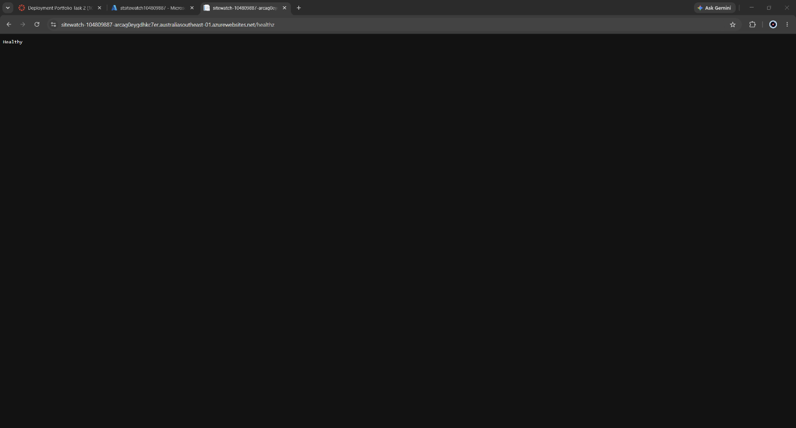

Diagnostic logging and real-time streaming
Application logging to the filesystem at Information level, web server (W3C) logging, detailed error messages and failed request tracing were all enabled on the App Service instance .
Filesystem-based application logging is automatically disabled by the platform twelve hours after being switched on, in order to protect instance storage from unbounded log growth. Evidence was therefore captured immediately after enabling the setting rather than at a later point in the work.
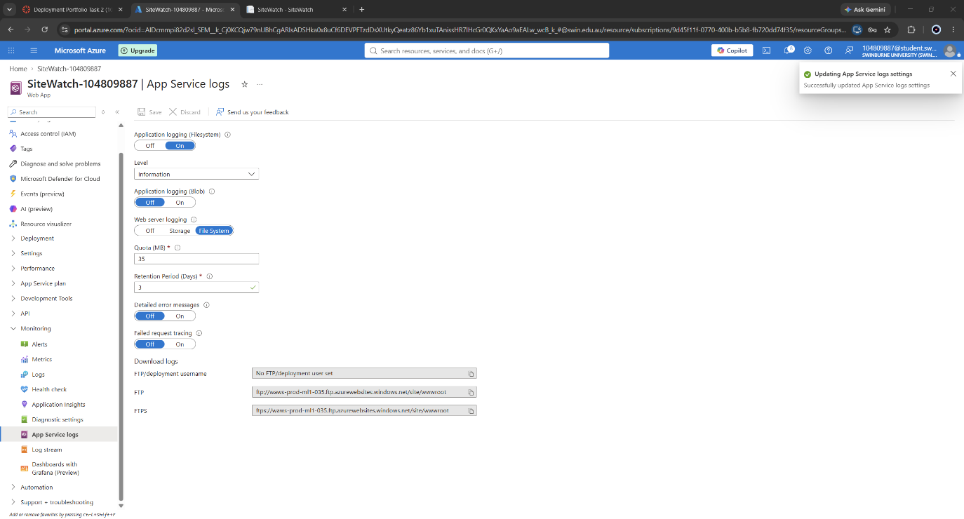
On the application side, the App Service diagnostics logging provider is registered during host construction so that ILogger output written by the application reaches the platform log stream. Every endpoint check emits a structured log entry recording the endpoint name, URL, resulting status code and elapsed time in milliseconds, so the application produces a continuous stream of genuine diagnostics during normal operation.
Real-time streaming was verified through the Azure Portal Log stream blade while traffic was generated against the live application in a separate browser session. The generated traffic included repeated requests to the status board and the API endpoint, and a deliberate request to a path that does not exist.
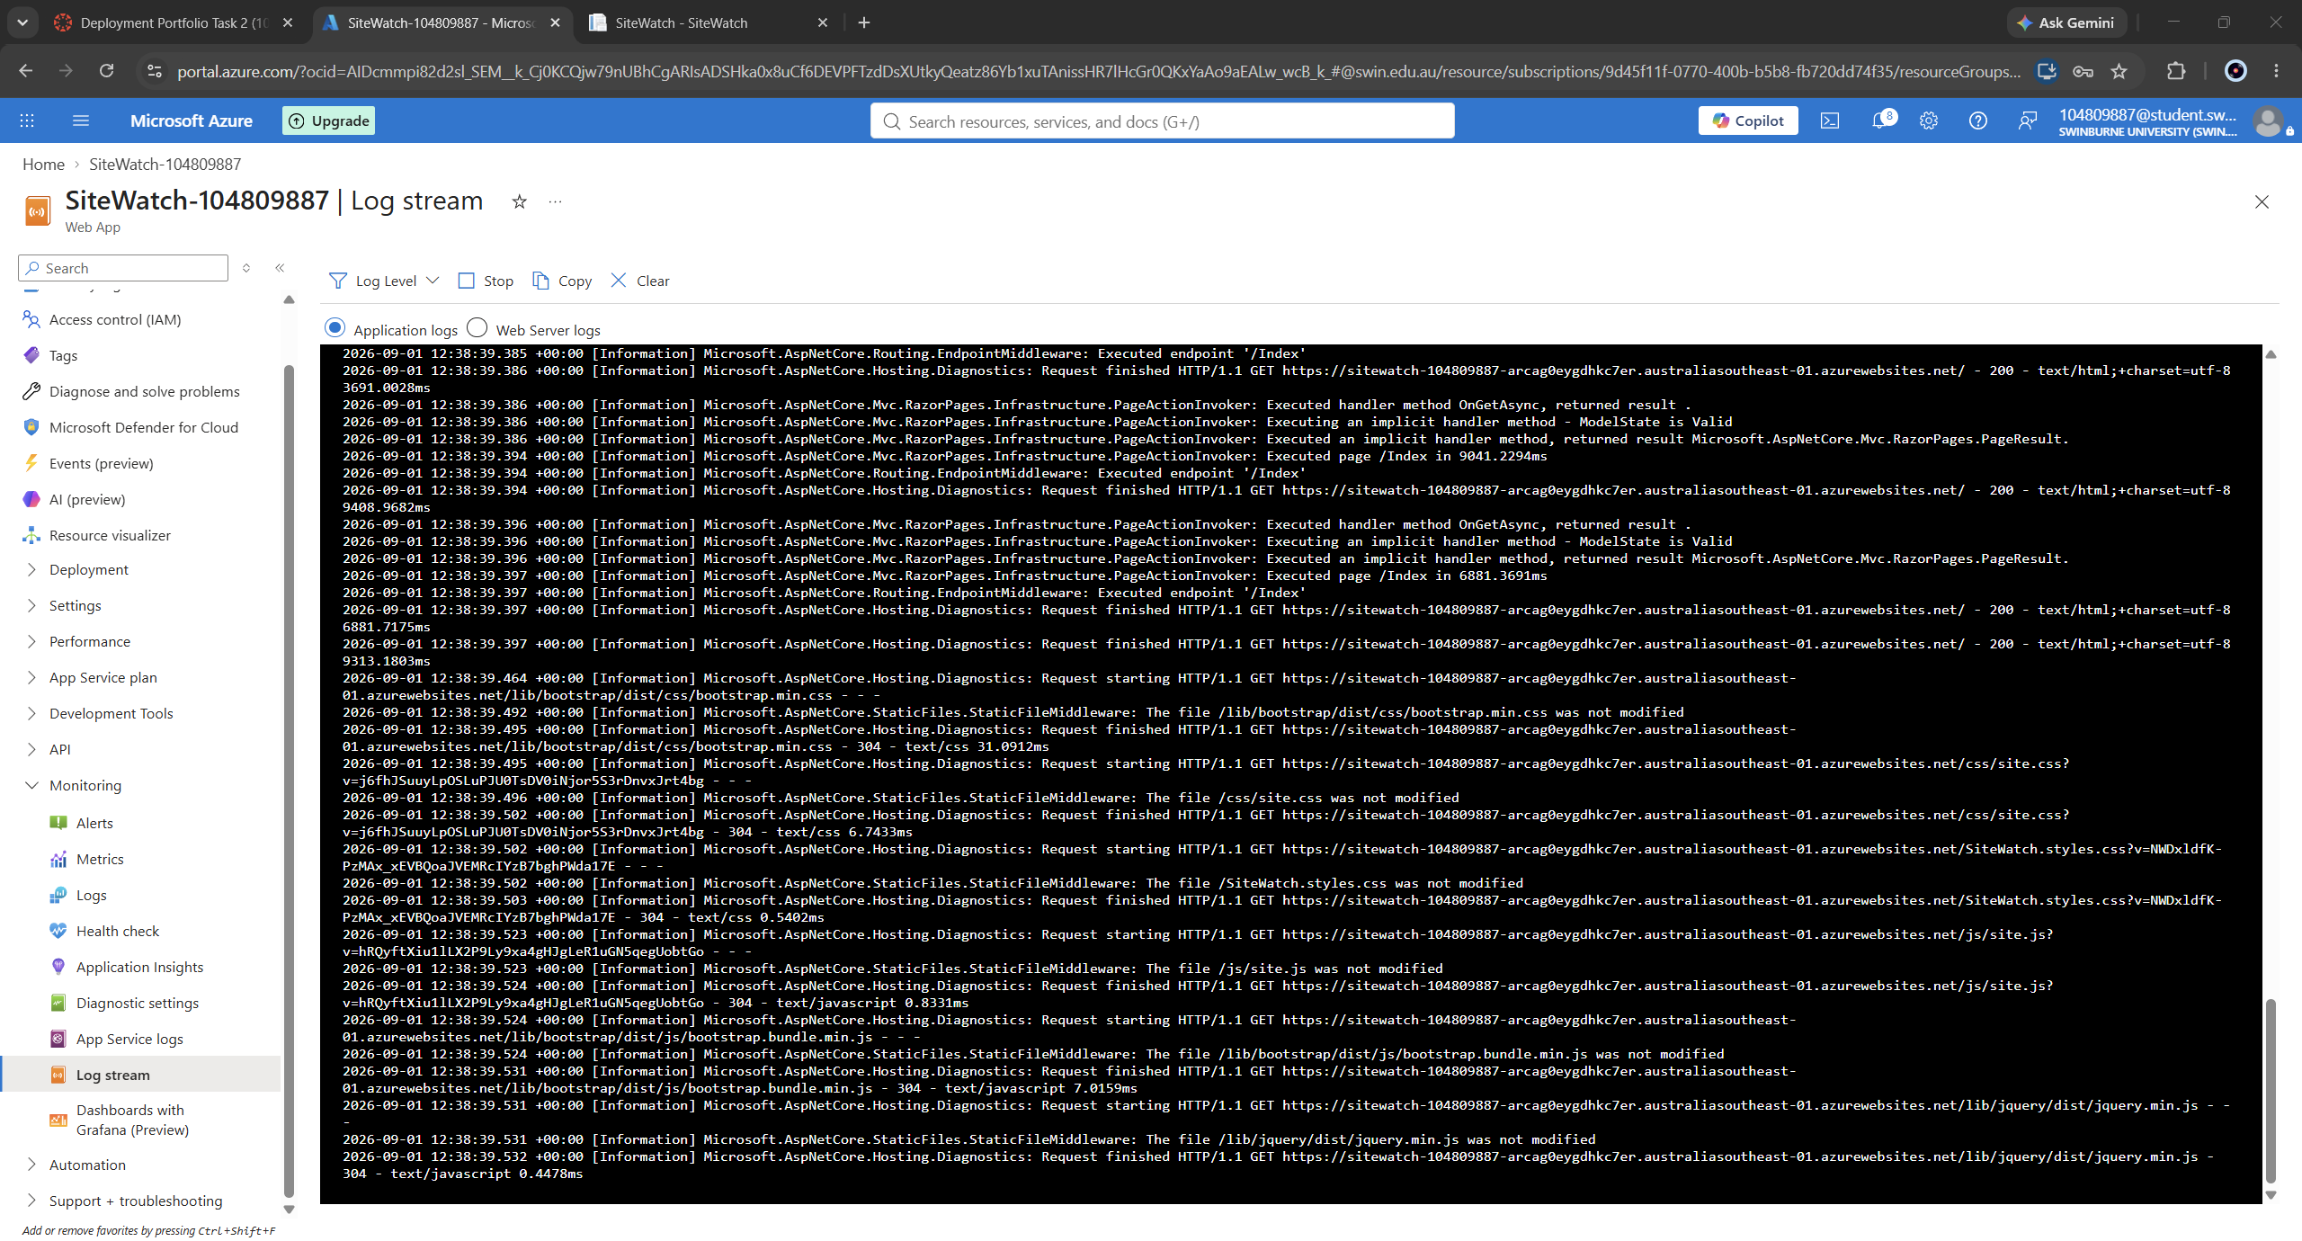

PROBLEMS ENCOUNTERED AND THEIR RESOLUTION
This section records the failures encountered during the deployment and how each was diagnosed and resolved. They are documented in full rather than summarised, because the diagnostic process is a substantial part of the work this task represents and because several of the failures illustrate properties of the platform that are not obvious from its documentation.

Incident 1 - Subscription not visible in Visual Studio (Swinburne tenant)
Symptom- The subscription visible in the Azure Portal under a Swinburne student account did not appear in the Visual Studio publish wizard's subscription dropdown. Selecting the subscription that was listed produced a deployment failure.
Diagnosis- The account was a member of a university-managed tenant holding a shared subscription, on which the account did not carry sufficient rights to create App Service resources. The unit walkthrough anticipates this condition and advises falling back to a personal account.
Resolution- All resources created under the student account were deleted, the account was removed from Visual Studio, and the work was migrated to a personal Microsoft account with its own subscription. Screenshots captured under the original account were discarded and retaken, so that all evidence in this report refers consistently to a single subscription.
Incident 2 - Unhandled exception at host startup from the OpenTelemetry exporter
Symptom- The application terminated at startup with System.InvalidOperationException: "A connection string was not found. Please set your connection string.", raised from Azure.Monitor.OpenTelemetry.Exporter during dependency injection container construction.
Diagnosis- Microsoft offers two instrumentation paths for .NET applications: the classic Application Insights SDK and the Azure Monitor OpenTelemetry Distro. The OpenTelemetry exporter had been added to the project. The two differ materially in failure behaviour: the classic SDK degrades silently when no connection string is configured, whereas the OpenTelemetry exporter throws during meter provider construction, which occurs before the host begins serving requests and therefore prevents startup entirely.
Resolution- The OpenTelemetry package was removed and the classic Application Insights SDK retained. Telemetry registration was additionally made conditional on the presence of a connection string, so that a monitoring dependency cannot prevent the application from starting. The general principle applied is that observability infrastructure should not be able to take down the system it observes.

Incident 3 - Browser safety warning on the assigned hostname
Symptom- Both Google Chrome and Microsoft Edge presented a "Dangerous site" interstitial for the assigned *.azurewebsites.net hostname while the application was still serving the platform placeholder page.
Diagnosis- The azurewebsites.net domain is shared across a very large number of tenants and is subject to reputation-based blocking by browser safety services independently of the content any individual application hosts. Both browsers consult the same Safe Browsing data, which is why the warning was consistent across them. The auto-generated hostname, combined with a site serving only a parked placeholder, matched the heuristic profile of abandoned infrastructure.
Resolution- The application was redeployed under a shorter, human-meaningful hostname and the warning did not recur. In a production deployment the durable mitigation is a verified custom domain carrying its own reputation, which on App Service requires a Basic tier or higher for a managed TLS certificate and is therefore outside the Free-tier constraints of this task.

DECLARATION OF GEN AI USE
Generative artificial intelligence (Anthropic Claude) was used during the completion of this assessment. The nature and extent of that use is declared below.
AI assistance was used for:
- Planning the sequence of work across assessment levels and identifying which evidence each rubric requirement demands.
- Drafting the source code of the SiteWatch application, including the configuration model, the monitoring service, the Azure Table Storage history store and the health check implementation.
- Diagnostic assistance when deployment and runtime failures occurred, including the incidents.
- Drafting the structure and prose of this report.
The following work was performed by the author without AI execution:
- Creation of the Azure account and subscription, and all authentication.
- All Azure Portal provisioning, configuration and diagnostic operations.
- All Visual Studio operations, including project creation, building and publishing.
- All screenshot capture and all verification of live endpoints.
- Identification of the symptoms that led to each incident, and confirmation of each resolution.
All AI-generated source code was reviewed, executed and verified by the author. All statements of platform behaviour in this report were confirmed against the cited Microsoft documentation, and all cited sources were opened and checked to support the claims attributed to them. Where AI-suggested approaches proved incorrect in practice - most notably the instrumentation package discussed in incident 2 - the error was identified through testing by the author and corrected accordingly.
This declaration is made in accordance with Swinburne University of Technology's policy on the use of generative artificial intelligence in assessment.

REFERENCES
[1] Microsoft, "App Service pricing," Microsoft Azure. [Online]. Available: https://azure.microsoft.com/en-us/pricing/details/app-service/windows/. [Accessed: «DD Mon. 2026»].
[2] Microsoft, "Inbound and outbound IP addresses in Azure App Service," Microsoft Learn. [Online]. Available: https://learn.microsoft.com/en-us/azure/app-service/overview-inbound-outbound-ips. [Accessed: «DD Mon. 2026»].
[3] Microsoft, "Configure an App Service app," Microsoft Learn. [Online]. Available: https://learn.microsoft.com/en-us/azure/app-service/configure-common. [Accessed: «DD Mon. 2026»].
[4] Microsoft, "Azure App Service plan overview," Microsoft Learn. [Online]. Available: https://learn.microsoft.com/en-us/azure/app-service/overview-hosting-plans. [Accessed: «DD Mon. 2026»].
[5] Microsoft, "Tutorial: Create and manage Azure budgets," Microsoft Learn. [Online]. Available: https://learn.microsoft.com/en-us/azure/cost-management-billing/costs/tutorial-acm-create-budgets. [Accessed: «DD Mon. 2026»].
[6] Microsoft, "Azure Storage redundancy," Microsoft Learn. [Online]. Available: https://learn.microsoft.com/en-us/azure/storage/common/storage-redundancy. [Accessed: «DD Mon. 2026»].
[7] Microsoft, "Configure an App Service app: Configure app settings," Microsoft Learn. [Online]. Available: https://learn.microsoft.com/en-us/azure/app-service/configure-common#configure-app-settings. [Accessed: «DD Mon. 2026»].
[8] Microsoft, "Configuration in ASP.NET Core," Microsoft Learn. [Online]. Available: https://learn.microsoft.com/en-us/aspnet/core/fundamentals/configuration/. [Accessed: «DD Mon. 2026»].
[9] Microsoft, "Health checks in ASP.NET Core," Microsoft Learn. [Online]. Available: https://learn.microsoft.com/en-us/aspnet/core/host-and-deploy/health-checks. [Accessed: «DD Mon. 2026»].
[10] Microsoft, "Monitor App Service instances using Health check," Microsoft Learn. [Online]. Available: https://learn.microsoft.com/en-us/azure/app-service/monitor-instances-health-check. [Accessed: «DD Mon. 2026»].
[11] Microsoft, "Enable diagnostics logging for apps in Azure App Service," Microsoft Learn. [Online]. Available: https://learn.microsoft.com/en-us/azure/app-service/troubleshoot-diagnostic-logs. [Accessed: «DD Mon. 2026»].
[12] Microsoft, "Logging in .NET Core and ASP.NET Core," Microsoft Learn. [Online]. Available: https://learn.microsoft.com/en-us/aspnet/core/fundamentals/logging/. [Accessed: «DD Mon. 2026»].
[13] Microsoft, "Introduction to Razor Pages in ASP.NET Core," Microsoft Learn. [Online]. Available: https://learn.microsoft.com/en-us/aspnet/core/razor-pages/. [Accessed: «DD Mon. 2026»].
[14] Microsoft, "Application Insights for ASP.NET Core applications," Microsoft Learn. [Online]. Available: https://learn.microsoft.com/en-us/azure/azure-monitor/app/asp-net-core. [Accessed: «DD Mon. 2026»].
[15] Microsoft, "Disable basic authentication in App Service deployments," Microsoft Learn. [Online]. Available: https://learn.microsoft.com/en-us/azure/app-service/configure-basic-auth-disable. [Accessed: «DD Mon. 2026»].
[16] Microsoft, "Azure.Data.Tables client library for .NET," Microsoft Learn. [Online]. Available: https://learn.microsoft.com/en-us/dotnet/api/overview/azure/data.tables-readme. [Accessed: «DD Mon. 2026»].
[17] Microsoft, "Quickstart: Deploy an ASP.NET web app to Azure App Service," Microsoft Learn. [Online]. Available: https://learn.microsoft.com/en-us/azure/app-service/quickstart-dotnetcore. [Accessed: «DD Mon. 2026»].

